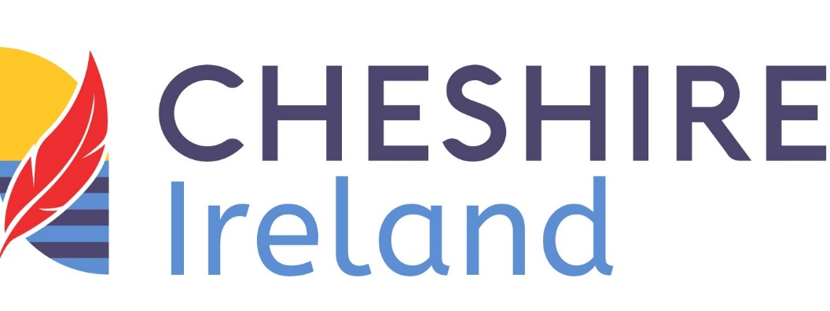

FAQs

WHEN IS MY DONATION ELIGIBLE FOR TAX RELIEF?
If you donate €250 or more in one calendar year and you pay income tax and/or capital gains tax in the Republic of Ireland, we can claim 45% tax back on your gift and make your generous donation go even further. This is at no extra cost to you.

HOW MUCH EXTRA MONEY WILL GO TO CHESHIRE IRELAND?
Up to 45%. For example, if you donate €250, Cheshire Ireland can claim an extra €112.25 from Revenue, making your donation worth €362.25.

WHAT DO I NEED TO DO TO MAKE MY DONATIONS GO EVEN FURTHER?
Each year we send tax forms to everyone who has donated at least €250. If you would like us to send you a form now, please email fundraising@cheshire.ie or call 01 2974100 or download the form here. Then just fill in your details, sign and return to us. Remember, it does not affect your tax situation in any way.

WHAT DOES ‘ASSOCIATED’ WITH THE APPROVED BODY (I.E. CHESHIRE IRELAND) MEAN?
You do not need to tick this box unless you are an employee or board member of Cheshire Ireland. Donors and volunteers are not considered as being ‘associated’ with Cheshire Ireland.
For further information from Revenue please click here.

